**Priority Scheduling**

Aditya(18csu011)

Python code in Jupyter Notebook:

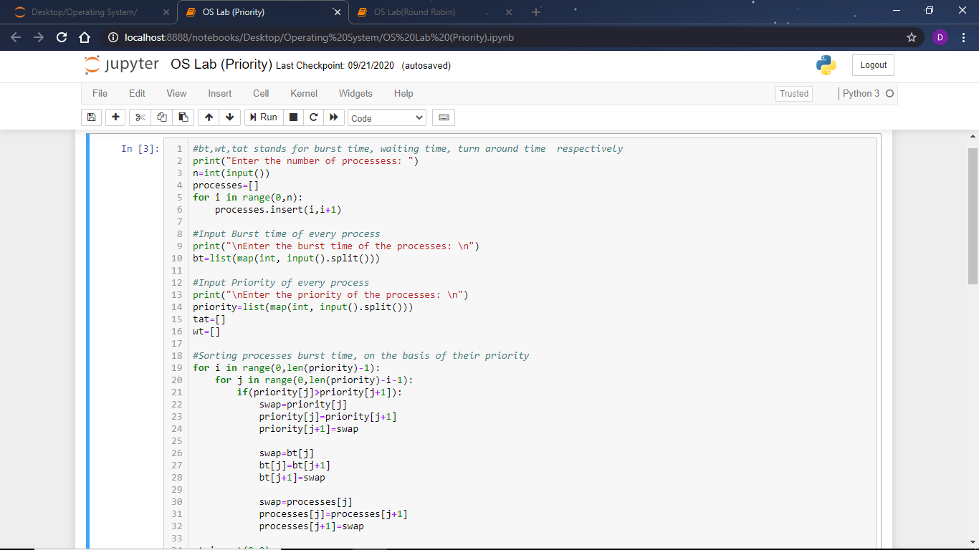

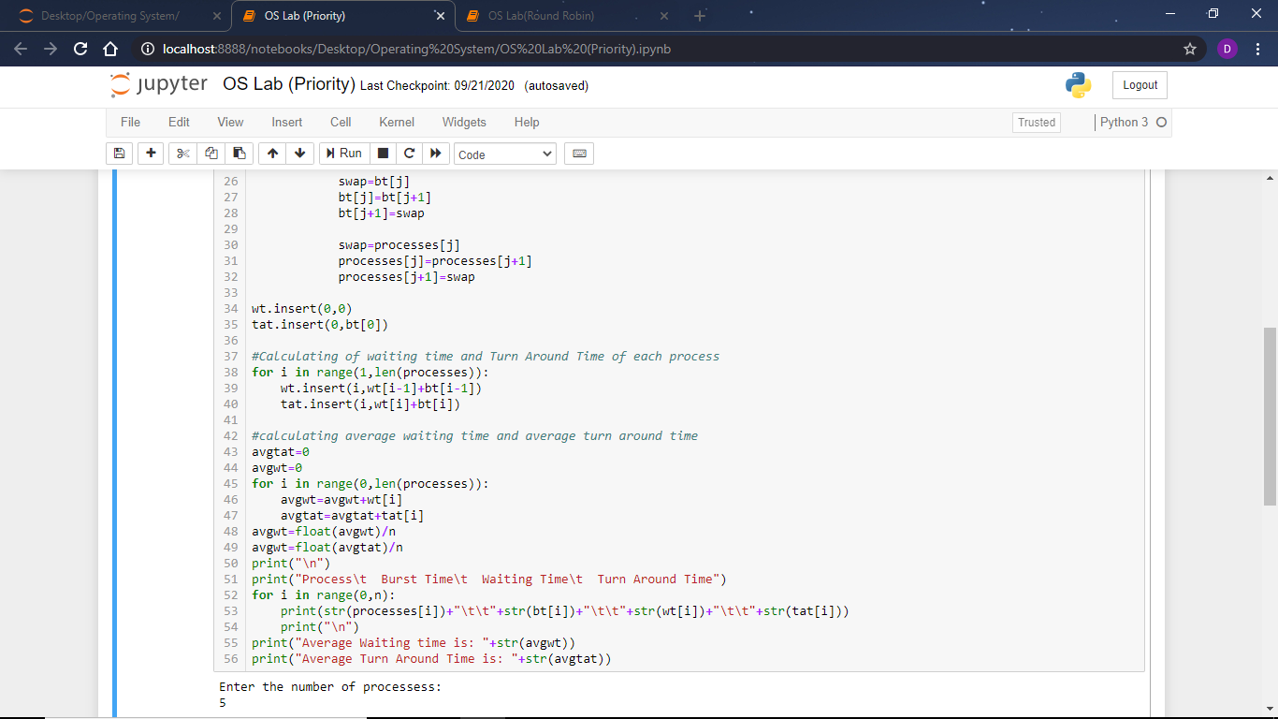

Output of the above code:

